**1.Abstract**

As the most important strategic resource around the globe, crude oil is the “key” commodity for the world‟s economy.Therefore forecasting it has been a challenging task as lot of events influence its price so it is very hard to forecast its prices.Crude oil price suffers fromhigh volatility and fluctuations. Recentlymany studies occurred to discuss theproblem of predicting oil prices andseeking to access to the best results.Forecasting its needs will be helpful for our goverment, Companies and Investors. This project invoves creating a artificial neural networks(ANN) to predict the price of crude oil. In this project, we propose a novel approach for crude oil price prediction based on aritfical.

**Keywords**: Crude oil, economy, energy, fuel, price.

**2.Litreature Survey**

**2.1 Application of Traditional and Statistical Econometric Models:**

Among many and different forecasting models that have been developed to predict the "black gold" price, the traditional statistical and econometric methods are the first ones to be applied by academic researchers. The first research about forecasting oil market is proposed by Amano (1987). The author used a small-scale econometric model for oil market prediction. Huntington (1994) utilized a sophisticated econometric model for predicting oil price in the 1980s. In another work, Gulen (1998) applied cointegration analysis to predict the WTI crude oil price. Barone-adesi et al. (1998) suggested a semi-parametric approach based on the filtered historical simulation technique to forecast oil price. Based on the GARCH properties of the oil price volatility, Morana (2001) employed a semi-parametric approach investigated by Barone-adesi et al. (1998) to short-term forecast of Brent crude oil price. In another work, Tang and Hammoudeh (2002) utilized a nonlinear regression to predict OPEC basket price. Using OECD petroleum inventory levels and relative stock inventories, Ye et al. (2002, 2005) adopted a simple linear regression model for short-term monthly prediction of WTI crude oil spot price. In a related study, Ye et al. (2006) included nonlinear variables such as low- and high- inventory variables to the linear forecasting model suggested by Ye et al. (2002, 2005) to predict short-run WTI crude oil prices. Using OECD stocks, non-OECD demand and OPEC supply, Zamani (2004) applied an econometrics forecasting methodology to short term quarterly WTI crude oil spot price. Lanza et al. (2005) investigated crude oil and product prices by utilizing the error correction models. Sadorsky (2006) applied multiple univariate and multivariate statistical models such as GARCH, TGARCH, AR, and BIGARCH to daily forecast of volatility in petroleum futures price returns. Slightly more recent, Dees et al. (2007) developed a linear model of the world oil market to predict oil demand, supply, and prices focusing mainly on OPEC behavior. Murat and Tokat (2009) investigated the relationship between futures and spot crude oil prices and therefore tested the ability of futures prices to forecast spot price movements using random walk model. Cheong (2009) adopted ARCH models to forecast crude oil markets.

On the other hand, more recent studies have applied GARCH as well as different models of the GARCH family to predict oil price. For example, Narayan and Narayan (2007) and Agnolucci (2009) used GARCH model to forecast spot and futures crude oil prices. In a related research, Mohammadi and Su (2010) compared the forecasting results of various GARCH-types models in order to predict the crude oil price. Kang et al. (2009) proposed CGARCH, FIGARCH and IGARCH models to forecast volatility of crude oil markets.

For the same pupose, Wei et al. (2010) extended the study of Kang et al. (2009) by applying linear and nonlinear GARCH-class models. As results of the application of linear techniques, a significant error has been demonstrated between actual and predicted oil prices. With these models, several exogenous variables have been employed to predict oil price, however; inventory, supply and demand are the mostly used factors. Supply and demand are relatively inelastic to price changes, subsequently, an inventory adjustment can be slow to happen which explains the major part of the difference between real and forecasted prices, especially for the short run (Hamilton, 2008). On the other hand, traditional statistical and econometric techniques are usually able to capture only linear process in data time series (Weigend and Gershenfeld, 1994). However, the oil prices behavior is characterized by a high nonlinearity and irregularity. Therefore, the mentioned models are not the appropriate choice to forecast the oil price.

**2.2 Artificial Neural Network (ANN):**

**2.2.1 Definition and Neuron Model Evolution**

**2.2.1.1 Definition**

ANN is an input-output mathematical model inspired from human brain functioning by adopting the same mode of acquiring knowledge through learning process. Fig. 1 summarizes an analogy between biological and artificial neuron.

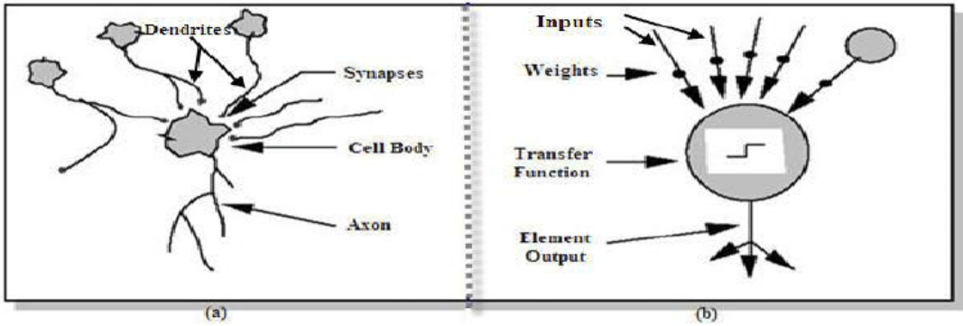

**Figure 1. Analogy between biological neuron (a) and artificial neuron (b)**

**2.2.1.2 Neuron Model Evolution**

**a) McCulloch & Pitts (1943) neuron model**

McCulloch & Pitts (1943) neuron model McCulloch and Pitts (1943) proposed the first artificial neuron also called formal neuron. Mathematically, the McCulloch-Pitts neuron model can be written as follows:

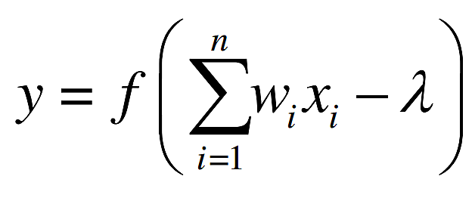

Where 1 2 x , x , ..., n x represent the McCulloch-Pitts neuron inputs that are exclusively binary values (zeros or ones), 1 2 , ,..., w w wn are the connections‟ weights received by the neuron. f is the sign function,  is the threshold and y is the output of McCulloch-Pitts neuron defined as:

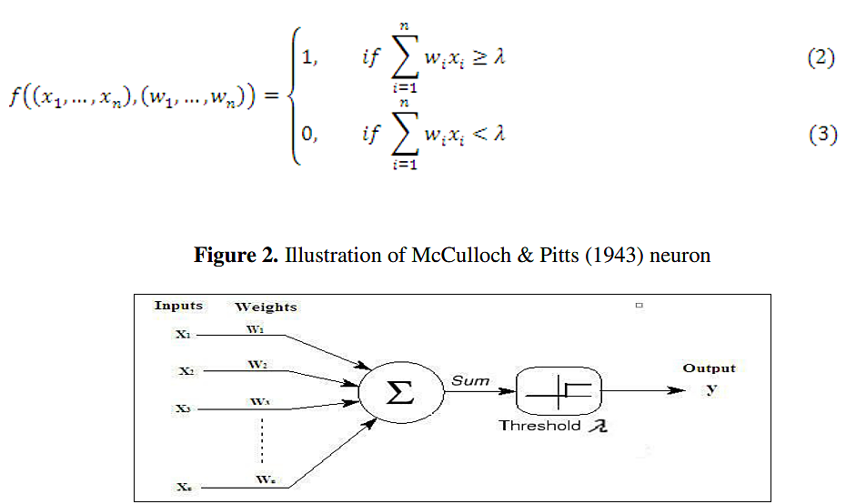

**b) Multilayer perceptron model**

Perceptron neural nets without hidden layers suppose only binary values of input-output as well as only two layers which explains the capability of the model to treat only the linearly separable functions. Windrow and Hoff (1960) introduce a learning rule called the delta rule consisting in modifying the connections‟ weights in order to reduce the difference between desired and actual output value. Therefore, the output value can take any value instead of 0 and 1. Minsky and Papert (1969) highlighted, in their book, the utility of adding one or more hidden layers to detect the complex features present in the inputs. The multilayer perceptron net was trained, traditionally, based on the backpropagation learning algorithm (detailed in the next section) developed by Rumelhart et al. (1986). The multilayer perceptron is composed of a layer of input units, one or more hidden layers and an output layer (see Fig .4).

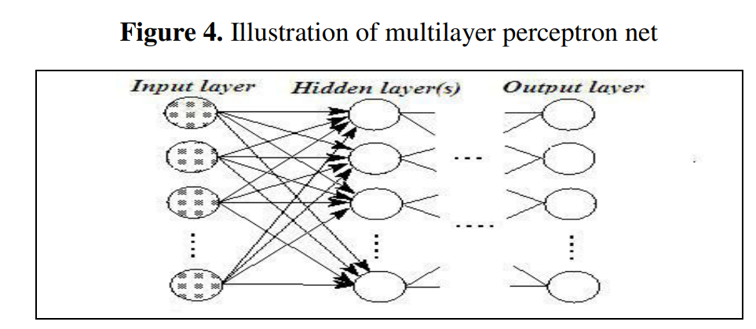

In this network system, the information propagates in a single direction„„forward‟‟: the input units pass the information to the neurons in the first hidden layer, the outputs from the first hidden layer are subsequently passed to the next layer, and so forth. Thus, the network output (for example, with one hidden layer) is :

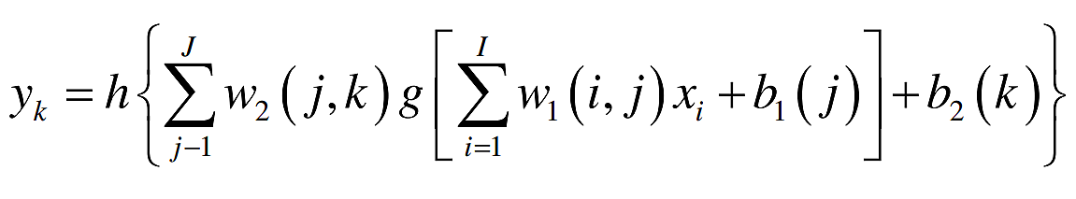

Where: i x are the input variables of the network; I is the number of input variables; J is the total number of nodes in the hidden layer; K is the number of neurons in the output layer; g and h are, respectively, the transfer/activation function of the first and the second layer; w1 is the weights matrix of the hidden layer; w2 is the weights matrix of the output layer; 1 b and 2 b are the bias vectors of the hidden layer and of the output layer, respectively. To note, at least one transfer function (see the next section for more description of transfer function) of the hidden layer must be nonlinear (Hornik et al., 1989).

**References:**

[1] Yu Runfang, Du Jiangze and Liu Xiaotao, “Improved Forecast Ability of Oil Market Volatility Based on combined Markov Switching and GARCH-class Model, Procedia Computer Science, vol. 122, pp. 415-422, 2017.

[2] K. Greff, R. K. Srivastava, J. Koutník, B. R. Steunebrink and J. Schmidhuber, "LSTM: A Search Space Odyssey," IEEE Transactions on Neural Networks and Learning Systems, vol. 28, no. 10, pp. 2222-2232, Oct. 2017.

[3] Mohammad Reza Mahdiani and Ehsan Khamehchi, “A modified neural network model for predicting the crude oil price”, Intellectual Economics, vol. 10, no. 2, pp. 71-77, Aug. 2016.

[4] Manel Hamdi and Chaker Aloui, "Forecasting Crude Oil Price Using Artificial Neural Networks: A Literature Survey," Economics Bulletin, AccessEcon, vol. 35, no. 2, pp. 1339-1359, 2015.

[5] Aloui, Chaker & Hamdi, Manel. (2015). Forecasting Crude Oil Price Using Artificial Neural Networks: A Literature Survey. Economics Bulletin. 35. 1339-1359.